1.the organization which has highest population inventory year with country and its city location

**Ans: Bengaluru**

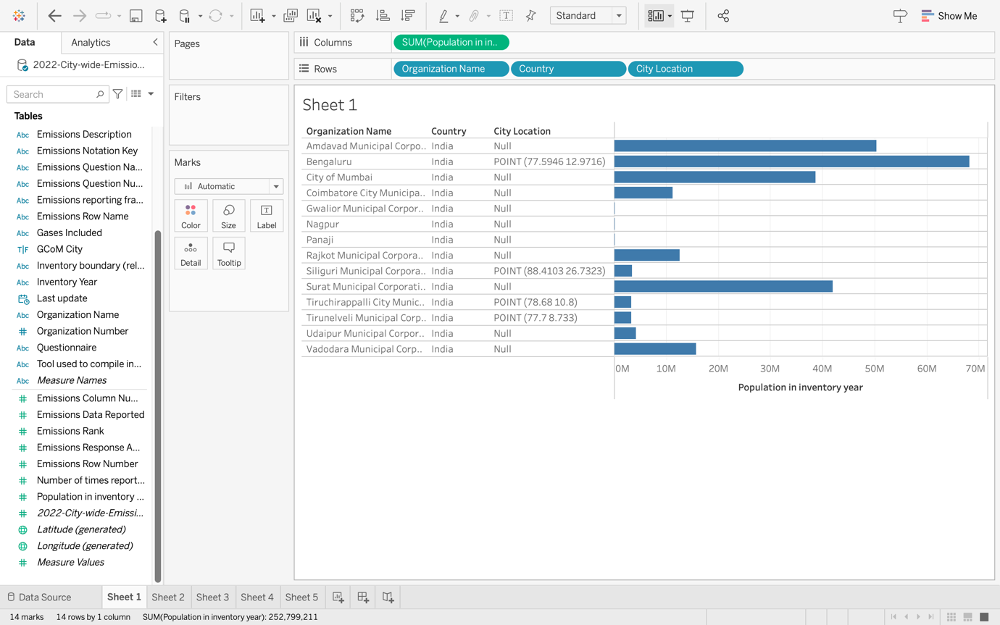

2. list the cities name those have minimum rank of 6

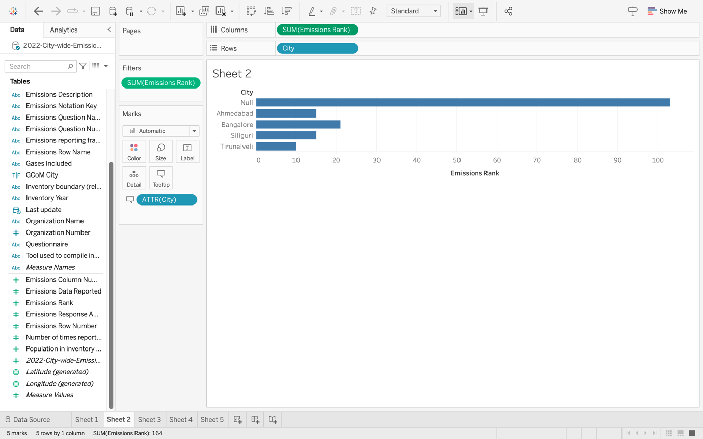

3. trendline between organizations and their emission data reported

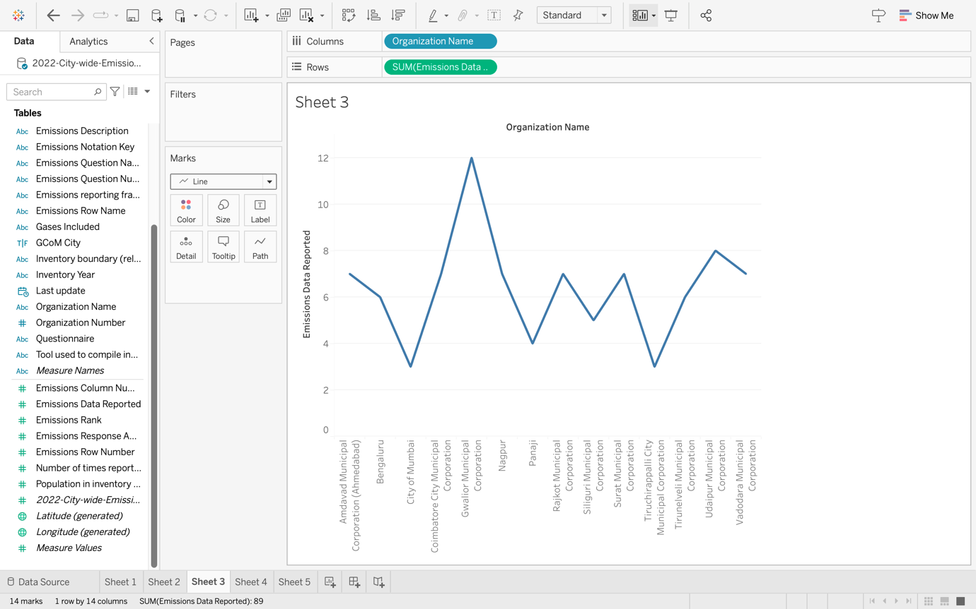

4. the emission gases with the emission data reported in each city of india

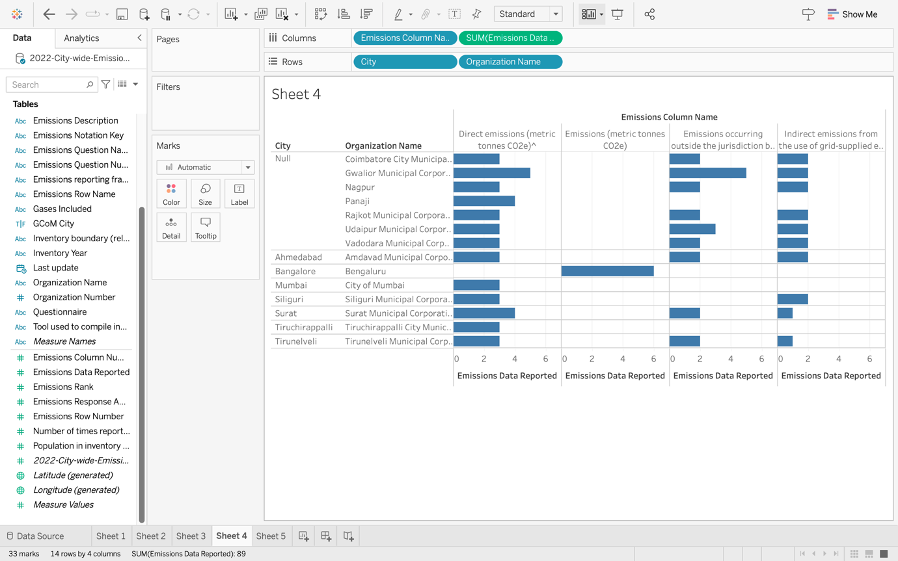

5. comparison between between India and USA regarding the gases included and their corresponding value from emission data reported.

